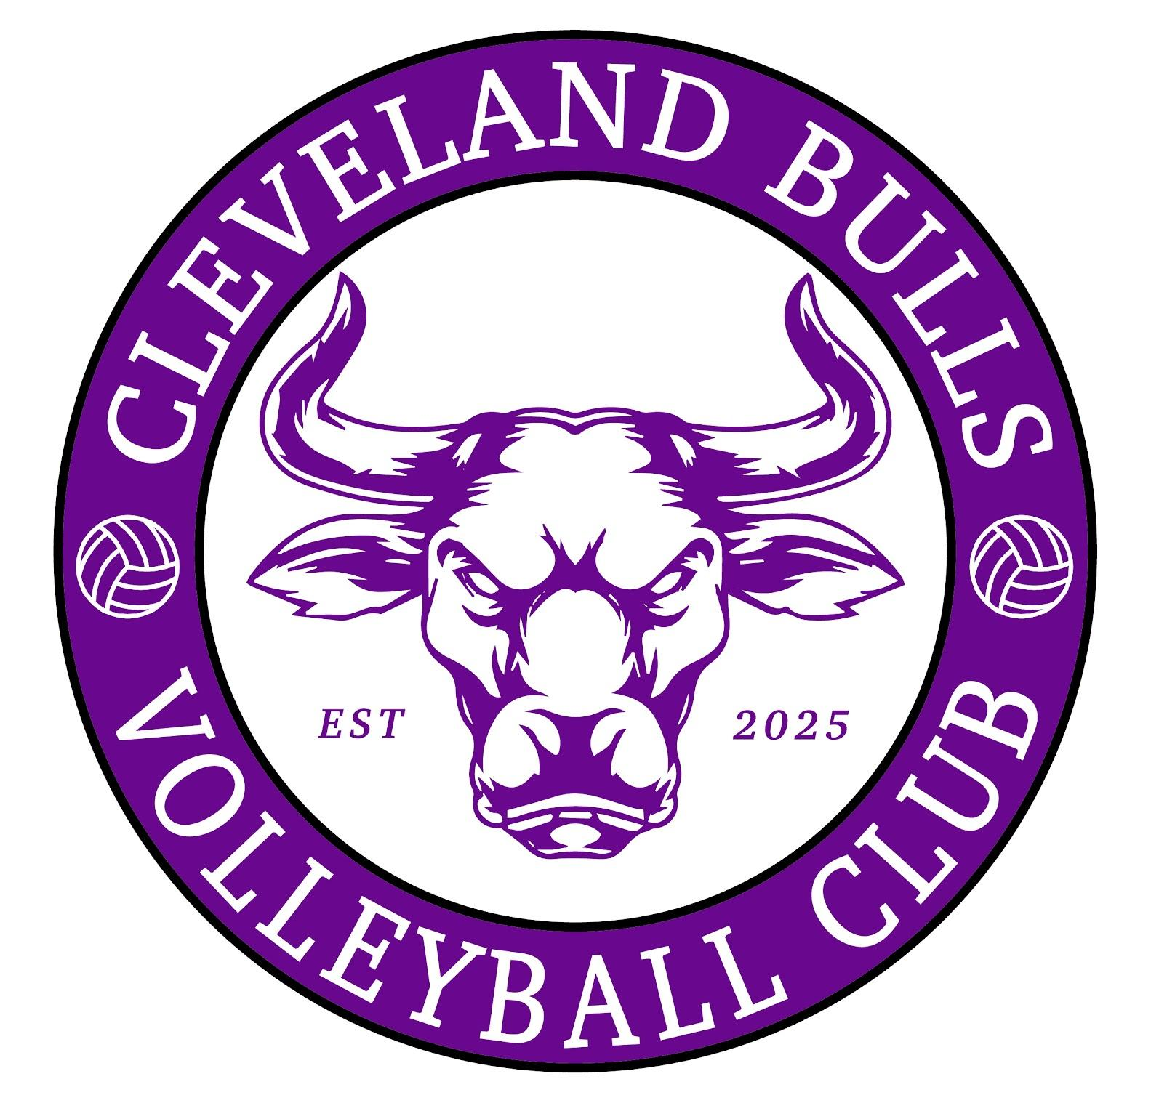

Mission Statement – Cleveland Bulls Volleyball Club

‘Cleveland Bulls Volleyball Club is committed to providing a supportive and engaging environment in which people are offered a quality volleyball experience that is fun, equitable, safe and welcoming.

We aim to provide an environment for both recreational and competitive play, catering for all abilities to achieve our goal for all members to relish the sport of volleyball.

We will support the development of volleyball within the Tees Valley Region, providing experiences and opportunities for players, coaches and officials to progress.

Cleveland Bulls Volleyball Club expects all members to contribute to the ethos and reputation of the club through respect and good sporting behaviour.’

